


Future Generation Computer Systems 19 (2003) 291–302

Distributed policy-based management of measurement-based
trafﬁc engineering: design and implementation
S. Van den Berghe∗, P. Van Heuven, J. Coppens, F. De Turck, P. Demeester
Department of Information Technology (INTEC), Ghent University, St. Pietersnieuwstraat 41, B-9000 Ghent, Belgium

Abstract
This article discusses an architecture using monitoring feedback as an assisting factor for delivering QoS on packet-based
networks. The handling of this feedback is done in an automated way, through the use of a policy-based management
architecture. For this, a formal model for describing data plane and measurement objects was translated into an XML-based
conﬁguration language. On top of this, a proof-of-concept management architecture was developed and evaluated, using both
a modiﬁed network simulator and enhanced Linux prototype routers.
© 2002 Elsevier Science B.V. All rights reserved.
Keywords: Trafﬁc engineering; Monitoring; Policy-based management; Real-time management

1. Introduction

1.1. Overview

In a networking environment where applications
become more demanding in terms of performance
requirements, the ability to offer QoS-guaranteed ser-
vices is considered to be an important added value for
Internet Service Providers. On the other hand, because
the network performance model of aggregated packet
streams is hard to determine, it is difﬁcult to provision
the network for every possible QoS requirement (as
expressed in a service level agreement). Admission
control algorithms, constraint-based routing algo-
rithms, etc. all use this limited model (e.g. assumed
residual bandwidth per link), and diagnostic moni-
toring of the actual network behaviour is needed to
check that their results are not too much impaired by
the uncertainties in the network performance model.
To avoid this, a bottom-up approach was developed

∗ Corresponding author.

based on a generic measurement infrastructure, aimed
at fulﬁlling the requirements as described in [9]. By
linking the measurement results with an automated
policy-driven (short timescale) management of tun-
nels in a multipath DiffServ over MPLS [6] environ-
ment, simulation results showed an adequate reaction
to short-term ﬂuctuation in network performance.
This paper describes the next step in this research:
porting the architecture on a Linux-based testbed. For
this, the necessary extensions to the Linux kernel were
developed in our laboratory [8], to allow for the neces-
sary functionality (DiffServ over MPLS, dividing traf-
ﬁc over multiple paths by mapping a set of classiﬁers
and monitoring).
To allow a ﬂexible conﬁguration, a description of
the capabilities of the extended router is translated
into a generic model for tunnel management. In ad-
dition, a proof-of-concept policy-based management
architecture is built, delivering Common Open Policy
Service (COPS)-like [3] paradigms through a CORBA
interface, and conﬁguring the automated decision
process through XML-encoded commands. For other

0167-739X/02/$ – see front matter © 2002 Elsevier Science B.V. All rights reserved.
PII: S 0 1 6 7 - 7 3 9 X ( 0 2 ) 0 0 1 5 4 - 1

292

S. Van den Berghe et al. / Future Generation Computer Systems 19 (2003) 291–302

information and operations, like topology analysis
and LSP-information retrieval, the software interacts
with corresponding signalling processes (an OSPF
routing daemon and RSVP-TE signalling daemon,
i.e. RSVP extended for end-to-end lsp conﬁguration).
After the description of the node and management
software functionality and algorithms, some tests
performed on the testbed are discussed. Here, users
are simulated by a set of SmartBits-generated [12]
streams from different edges of the network, and an
analysis is made as to how the algorithm handles
these trafﬁc ﬂuctuations. The resulting charts are
analysed in terms of improved network performance,
and compared with the same setup in the simulations.
In the third section, a conclusion is drawn from these
practical experiences with a short-term automated
management system, and future extensions are looked
at. These include a generalization to policy-based tun-
nel management (i.e. application in overlay IP-in-IP
networks or secured VPN tunnels) and even in sample
service deployment without tunnelling mechanisms.

1.2. Related work

The use of monitoring to optimize network provi-
sioning in near real-time is under study within several
major research projects. The concept of a two-level
trafﬁc engineering was used in the TEQUILA ap-
proach [13]. Here, a major part of the provisioning was
done based on speciﬁcations (SLSs) provided by the
users describing the requested service. In order to han-
dle ﬂuctuations in the network (occurring due to the
probabilistic nature of the SLS speciﬁcation and pro-
visioning algorithms), monitoring information is given
as an input to admission control, queue management
and tunnel management. The approach taken in this
paper simpliﬁes this model (by restricting itself to tun-
nel management), and on the other hand enlarges the
role of this dynamic part of network management. The
concept of a uniﬁed measurement architecture and its
relationship with trafﬁc engineering will also be inves-
tigated during a recently started IST project SCAMPI.
The concepts of policy-based management is also
being reﬂected in the work done in the IETF’s
Resource Allocation Protocol (RAP) working group.
Especially, the recent standardization of a feedback
framework that allows policy decisions to be taken
based on status reports from the network provides a

powerful framework for adaptive network manage-
ment. Publications on the subject of adaptive manage-
ment and trafﬁc engineering were published at recent
PAM and Infocom conferences [1,4].

2. Architecture and algorithms

As mentioned in Section 1, a policy-based man-
agement approach was chosen to drive the short-term
trafﬁc engineering. This implies that each network
element has a Policy Enforcement Point (PEP), which
controls the functionality and executes operations on
the network element. The decision to perform an op-
eration is taken by a more central Policy Decision
Point (PDP), which will use information reported by
the PEPs. As opposed to the classic Internet Engineer-
ing Task Force (IETF) approach, the PDP is not cen-
tralized, but distributed over all the ingress nodes (to
take decisions for that ingress locally), and a PEP can
communicate with multiple PDPs (more speciﬁcally,
multiple PDPs can use reports from a single PEP in
their decision process), as depicted in Fig. 1.
Creating new conﬁgurations, and performing oper-
ations on them, is done by instantiating and manipu-
lating objects (e.g. representing an LSP) in the PEPs.
Reporting can be done in two ways: solicited and un-
solicited. In the ﬁrst mode, a report is immediately
sent as a response to an execution performed in a PEP.
This type of report can be sent from PEP to PDP or be-
tween PEPs (e.g. a PEP on the ingress of an LSP, may
request statistics from the egress PEP). Unsolicited re-
ports are sent asynchronously, and can only be going
from PEP to a PDP.
In order to describe the actions, a formal model is
made, which describes the different entities on which a
PEP can execute operations. In the current architecture
these can be divided in two major categories, namely
data plane and monitoring:
1. Data plane. At the data plane level, packets trav-
elling through the ingress node, encounter three
packet-processing steps. As the ﬁrst step, the
classiﬁer will map a packet onto an LSP, and de-
termine the per hop behaviour (PHB) it should
receive in the network. After this, the packet is en-
capsulated in an MPLS packet (in the LSP block)
and queued/scheduled on the output according to

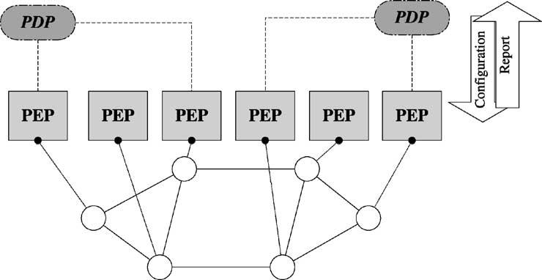
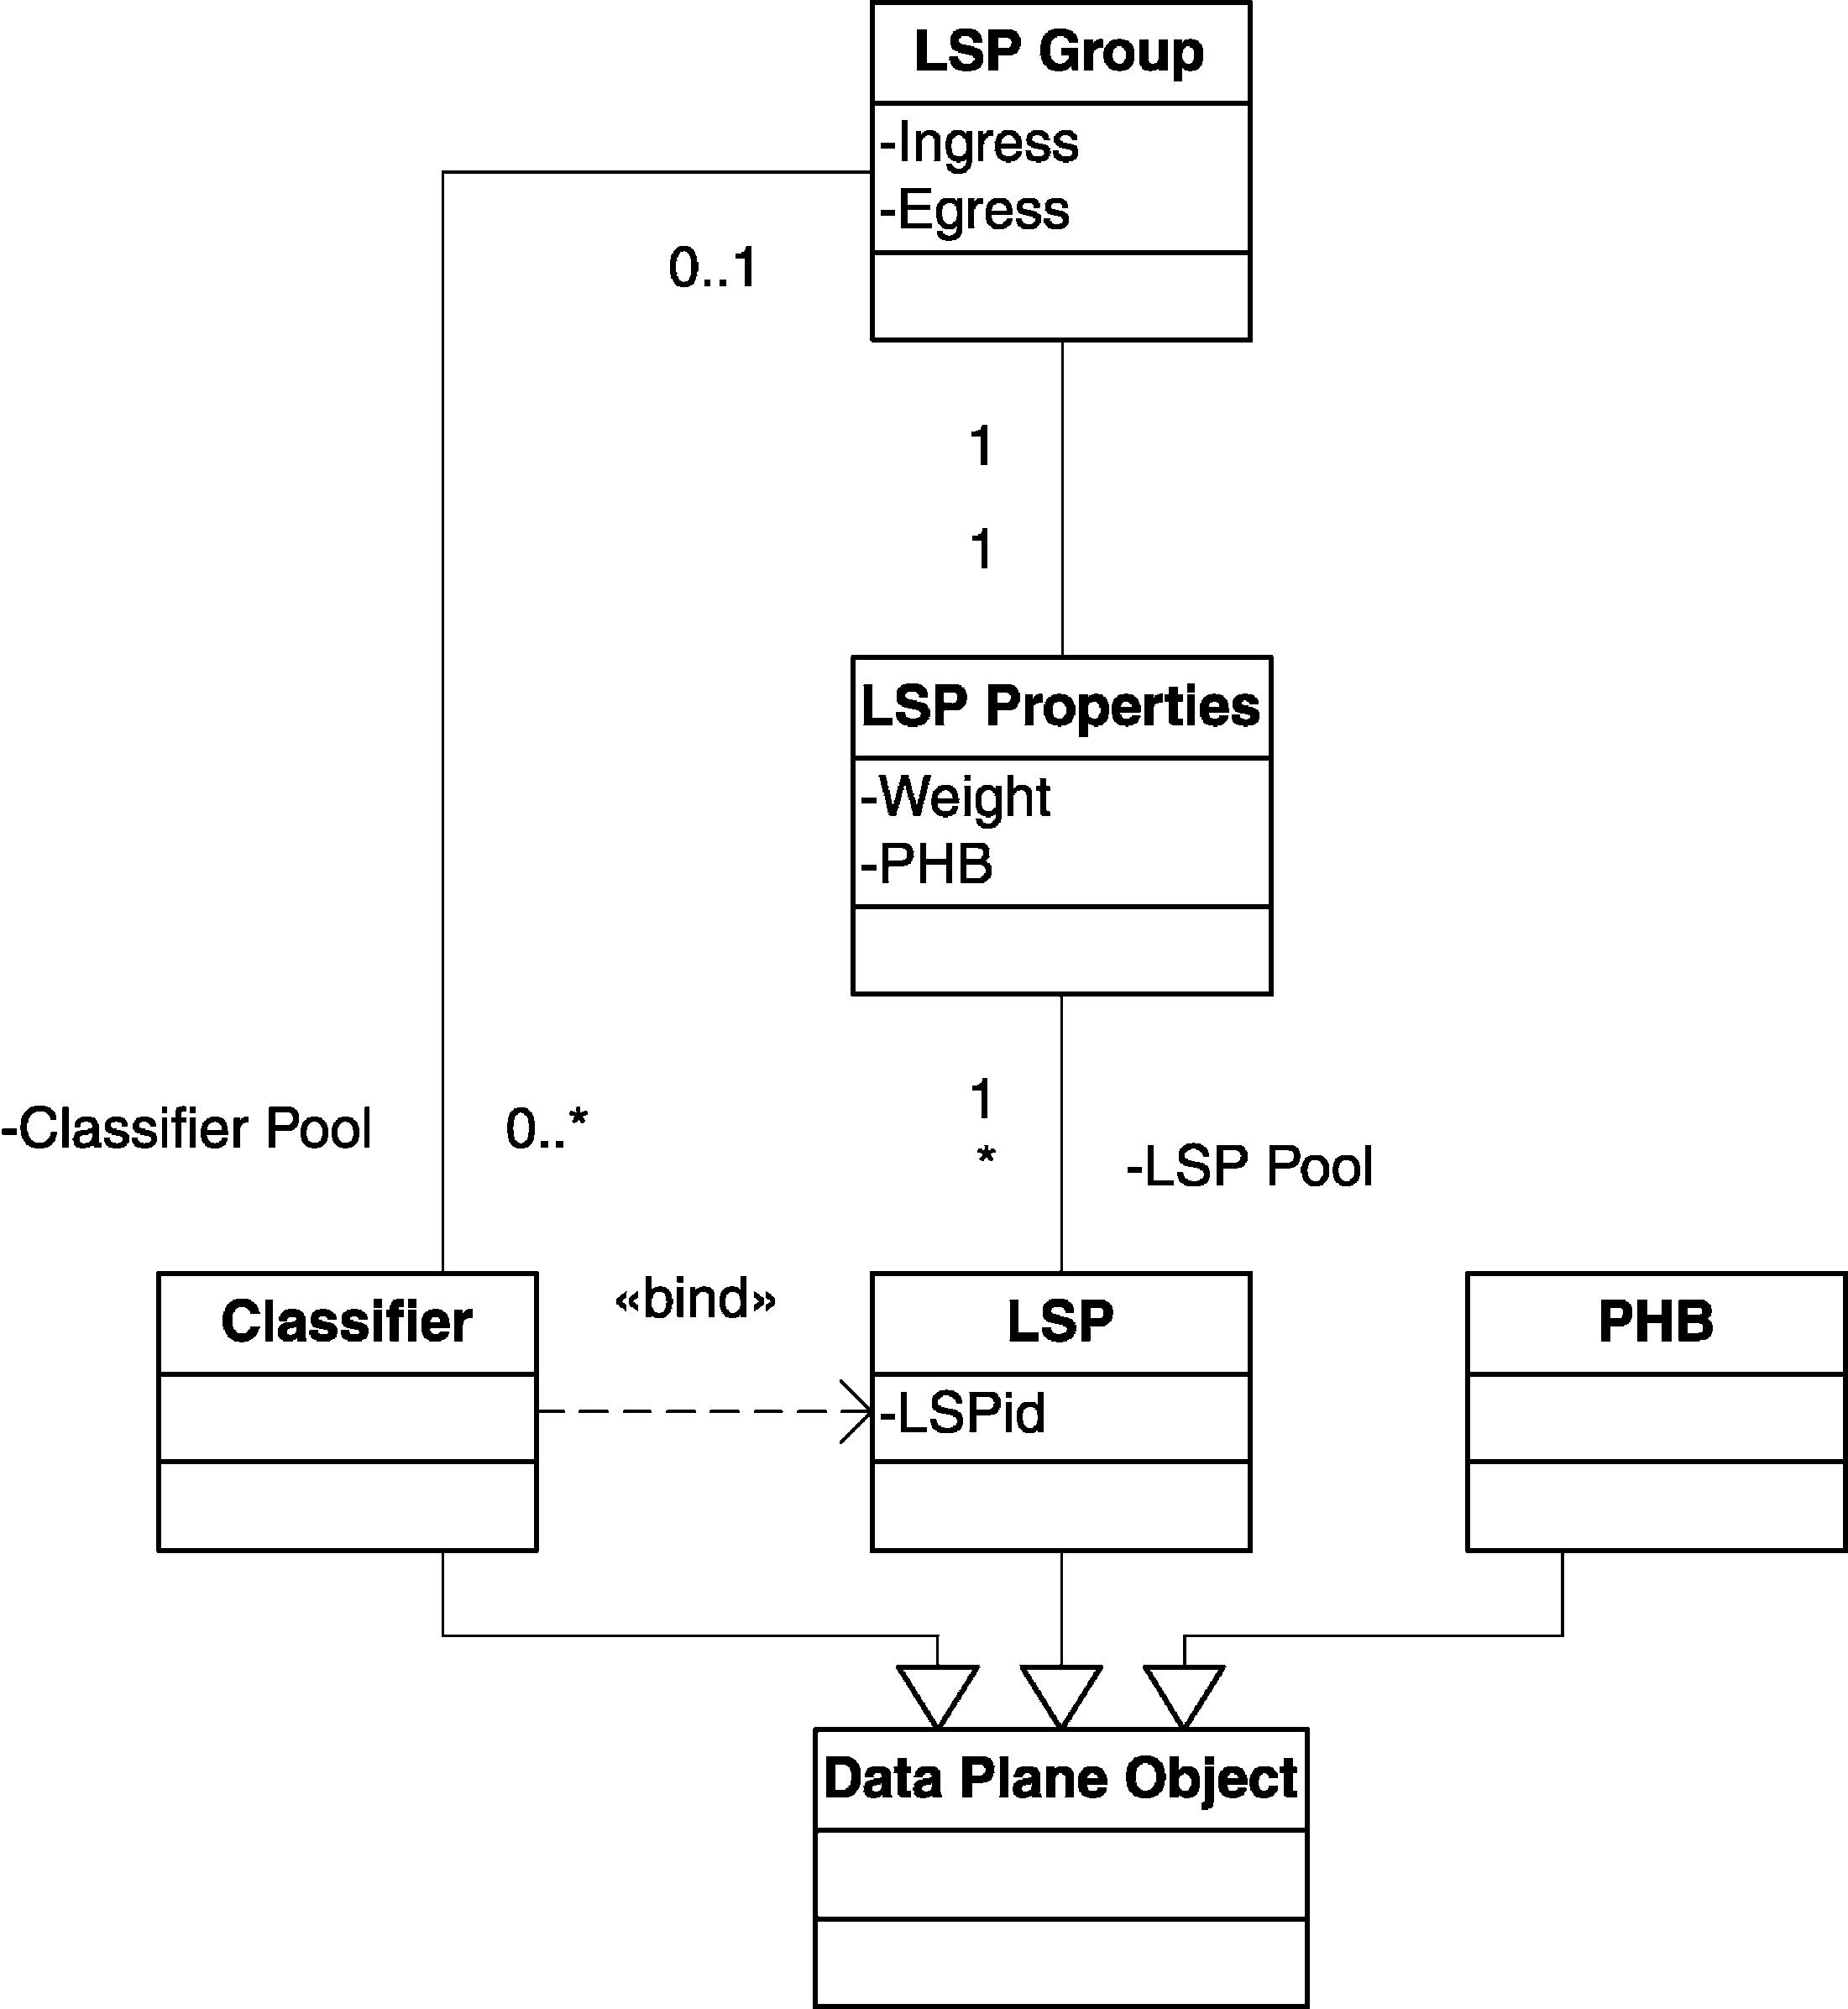

S. Van den Berghe et al. / Future Generation Computer Systems 19 (2003) 291–302

Fig. 1. PDP–PEP–network relationship.

293

a given PHB. The role of the PDP decision will be
to manage the way classiﬁers are bound to LSPs.
In order to do so an additional semantic class, the
LSP group, is introduced in the model. An LSP
group keeps track of both the corresponding set of
the classiﬁers and LSPs for each PHB and for each

egress. Each LSP in the LSP group is also tagged
with a weight variable, which is used in the algo-
rithm to keep track of the performance history of
the LSP (a higher weight means less performance
problems in the past). A more formal description
of this model is given in Fig. 2.

Fig. 2. Model data plane.

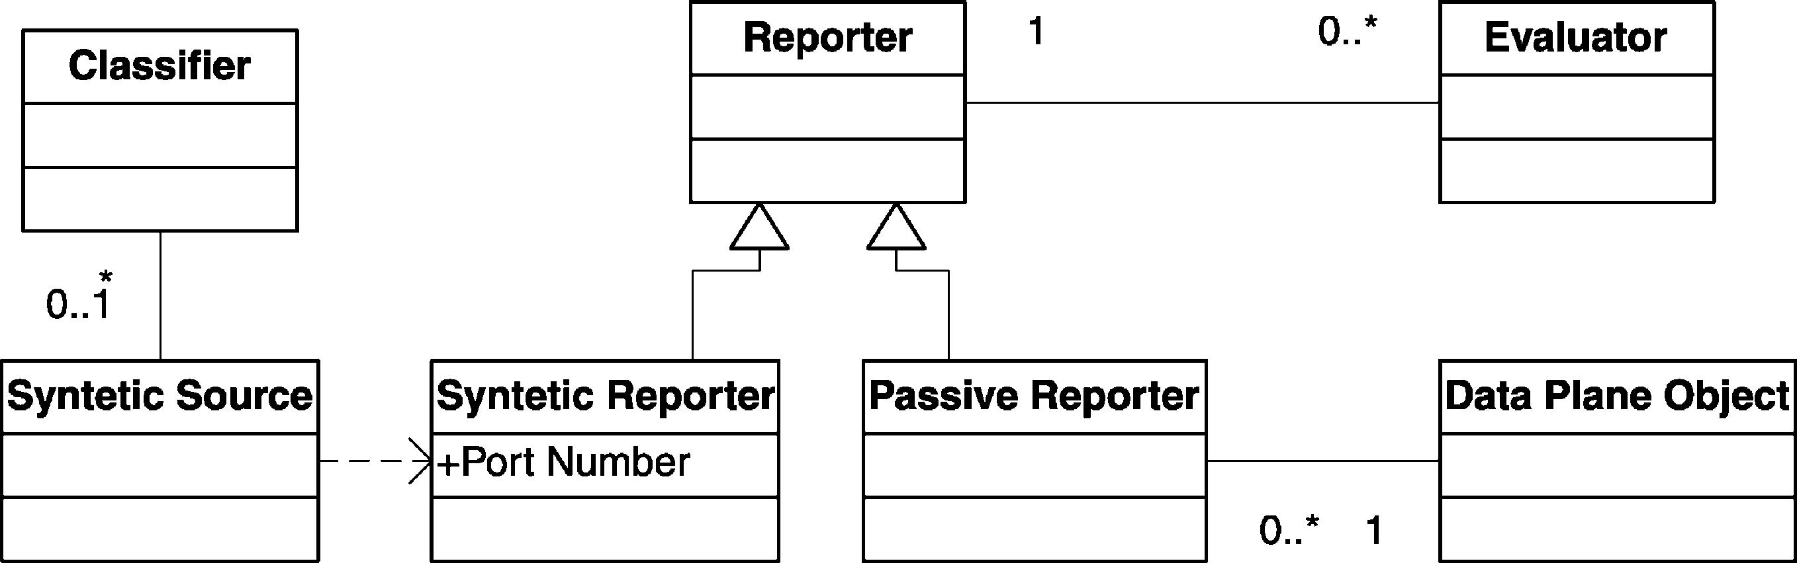

294

S. Van den Berghe et al. / Future Generation Computer Systems 19 (2003) 291–302

It is important to note that an LSP can belong to for the UDP test stream generated by the synthetic
multiple LSP groups. This ability allows the sup- source that is installed at the source PEP. The
port of both L-LSPs (where the trafﬁc of an LSP triplet (source address, destination address and
is mapped to a single PHB, deﬁned by the label) destination UDP port) uniquely deﬁnes the test
and E-LSPs (where the mapping on the PHB is session. Observe that in certain circumstances (e.g.
not given by the label, but by another ﬁeld—the to actively monitor an LSP), the injected packets
so-called exp-ﬁeld—in the MPLS header). In the need to be classiﬁed, in which case a classiﬁer for
second case, a single LSP can carry trafﬁc of mul- this triplet is installed. This conﬁguration approach
tiple service classes, so it belongs to multiple LSP replaces the control-plane signalling as deﬁned in
groups. [11].

2. Monitoring. One of the authors worked in the IETF
on the speciﬁcation of architectural requirements
for getting useful measurements for performing
trafﬁc engineering, resulting in [9]. This document
describes both the methodology requirements and
the metric involved in measurement for trafﬁc en-
gineering. Two main types of measurements have
been identiﬁed. The ﬁrst one is based on keeping
statistics inside queues, forwarding engines, etc.
Getting the results offered by these counters is
called a passive measurement. The class offering
this is modelled as a passive reporter, which is
connected to a data plane object for getting the
actual counters (in the current implementation,
“octets received” counters are offered for classi-
ﬁers, LSP and PHB objects) (Fig. 3).
The second option is to perform a “ping”-like
measurement: inject packets into a network as a
test stream from a source to a destination, and anal-
yse the quality with which they were transported.
In this work (roughly based on the concepts in
[2]), within an active monitor the sender side will
be described as a synthetic source, and the receiver
Both active and passive reporters will submit
their results, at conﬁgured read-out intervals, to an
analysing class, referred to as evaluators. Not only
does this allow for a ﬂexible analysis, but it also
improves scalability of monitoring (by pushing
measurement aggregation and analysis as close to
the wire as possible).
The evaluator can analyse measurement results
in two operational modes (“greater or equal” for
upper threshold checking or “lower than” for lower
thresholds) and can operate in different ways. In
the current implementation, three different types
are supported. The ﬁrst one, a ﬁxed classiﬁer
will be triggered whenever de metric is bigger
(or smaller) then a conﬁgured value. The second
type, a linear classiﬁer will be triggered accord-
ing to a probability p(x) for measurement result
x, upper border u and lower border l, as given
for upper threshold checking in Eq. (1). Finally,
a pseudo-evaluator is also available which will
simply report every value (e.g. for diagnostics).

 0, x ≤ l,

an active reporter. In order to conﬁgure the active
measurement, the reporter is installed by the des-
p(x) =
x − l
 h − l^{, h}≤ x < l,
(1)

tination PEP, electing a new free destination port

Fig. 3. Model monitoring.
1,
x > h.

S. Van den Berghe et al. / Future Generation Computer Systems 19 (2003) 291–302

295

2.1. Operations

Given these building blocks, actions are deﬁned
by XML-encoded strings that are transported using
a CORBA interface on the PDP and PEP. At the
PEP side, this interface offers the functions install
for adding new actions (and of course also a function
to remove them) and execute for actually performing
them. Once installed, an action is assigned an object
identiﬁcation by the PEP, for use in later reference. The
format of this identiﬁer is <object routerId=r
objectId=o>. Other actions are described by link-
ing object identiﬁers together in action XML strings
(observe that router identiﬁers are the same for both
operands, since the operations are performed inside
the PEP):
<action oper=operation>
<object routerId=r objectId=o1>
<object routerId=r objectId=o2>
</action>
The most important actions used in the current work
are:
• lspgroup → add(lsp or classiﬁer): adds a classiﬁer
or lsp to an lsp group (and corresponding remove
operations).
• lspgroup → decr(lsp l): takes a classiﬁer away
from l, decreases the weight of l, and re-maps the
classiﬁer to the lsp with the highest weight (and
different from l) in the LSP group.
• lspgroup → incr(lsp l): increases the weight
of l.
• object → show: used on any object, to immediately
report back conﬁguration information.
• object → showstats: used on any object, to imme-
diately report back statistics information.

The increase/decrease functionality is used to manage
the amount of trafﬁc on an LSP, and the two show
functions are for triggering solicited feedback. An ex-
ception to the action speciﬁcation format is the cre-
ate operation for actually creating new objects of a
certain type (e.g. LSP, Classiﬁer, etc.). The speciﬁca-
tion describes object speciﬁc elements (e.g. path of the
LSP). The creation of objects, and operations on them
uses the same structure and both yield a new object
identiﬁer:
<action oper=‘‘create’’ object=Object
Type>
Speciﬁcation
</action>
The PDP side offers a report interface operation,
which in this case is only called if an evaluator is
triggered to send an unsolicited report. There is also
an interface operation to deﬁne rules, which declares
a binding between two object identiﬁers at the PDP
level: one to identify the rule triggering object (e.g. an
evaluator) and one to identify the action to be taken
(which can either be an operation on an existing object
or the creation of a new one):
<action oper=operation>
<trigger routerId=r objectId=o1>
<object routerId=r objectId=o2>
</action>
The top-level auxiliary ﬁle: tsvdbels2.au.

2.2. Algorithms

As an example of the possible applications of the
means described above, we ﬁrst describe the algo-
rithm used in later experiments. Per LSP, two rules
and corresponding actions are deﬁned. To each LSP,
two evaluators are attached: a ﬁxed one for a lower
threshold and a linear one for upper threshold check-
ing, both using input from a passive monitor watch-
ing end-to-end tunnel loss (i.e. a passive reporter at
the ingress, which requests solicited usage report from
the egress, and calculates difference between sent and
received).
If for a given LSP the upper threshold evaluator is
triggered, its weight is decreased and one classiﬁer is
swapped to another LSP, selected by the maximum
weight. Secondly, if the monitored loss of an LSP is
below the lower threshold, its weight is increased. In
this way, the weight represents how willing an LSP
is to take extra classiﬁers from other LSPs that have
become overloaded, and do nothing if everything on
the network seems all right. To summarise, the deci-
sion process is described by the algorithm given below
(using the operations deﬁned previously), where the
LSPs are all part of the LSP group G = {L1, . . . , Ln}.
Every measurement result is checked against evalua-
tors eu(i) and el(i), both sending a report to the ingress

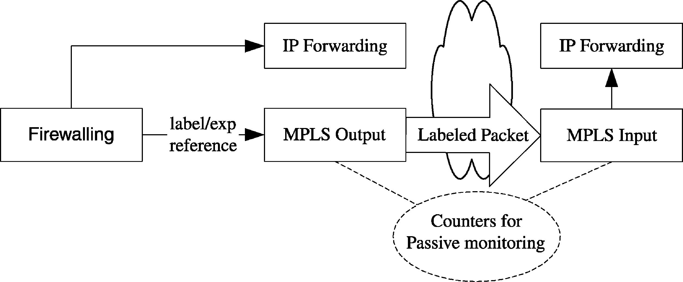

296

PDP when triggered:
ωi = 0, ∀i ∈ G

S. Van den Berghe et al. / Future Generation Computer Systems 19 (2003) 291–302

MPLS label at the egress (out-segment of the LSP), it
continues on a normal IP path. Passive monitors are
looking at trafﬁc entering and leaving the LSP (using
a solicited report from the ingress to the egress).

start evaluator eu(i) for lsp li , ∀i∈G
start evaluator el(i) for lsp li , ∀i∈G
loop
if condition eu (i) arrived then
G → decr(li )
else if condition el (i) arrived then
G → incr(li )
end if
end loop

3. The enhanced Linux router

The algorithm below was deployed in both a simula-
tion and a Linux-based router testbed. The Linux ker-
nel provides an advanced trafﬁc control to implement
DiffServ PHBs natively, and through an extension,
MPLS support. However, the combination of both was
not available. Furthermore, we needed a multi-ﬁeld
classiﬁcation before making a forwarding decision (in
order to drive the mapping of trafﬁc on an LSP). Since
the classic DiffServ-on-Linux classiﬁers are in the out-
put part of the network stack, the ﬁrewalling code was
reused to achieve these goals. Together with the im-
plementation of RSVP-TE signalling, this extension
was published to the open source community.
To summarise, the enhanced Linux router as shown
in Fig. 4, uses the result of ﬁrewalling to put pack-
ets on the right LSP, with the correct outgoing label
and exp-ﬁeld (in-segment). This is then used to select
the PHB throughout the network. After popping the
In the current approach, a choice is made to keep
most of the complexity of the architecture at the edges
of the network. The core-PEP is limited to the man-
agement and reporting of its local trafﬁc control, and
is a light-weight implementations of its much more
powerful cousins at the edge.
Operations in the core, like LSP establishment are
performed through signalling. This implies that PEPs
must communicate with the corresponding signalling
blocks, which in our case are an OSPF daemon (for
topology discovery) and an RSVP-TE signalling dae-
mon (for LSP control).

4. Results

4.1. Environment

To validate this architecture, the simulator ns-2 [10]
was modiﬁed and used. The PEP–PDP functionalities
were written outside the simulator (in order to be able
to reuse the same codebase for the testbed) and com-
munication between management and the simulator
was done using CORBA-calls. The topology and con-
ﬁguration used is shown in Fig. 5. This contains ﬁve
nodes (shown as 0 through 4) that actually constitute
the network under test. In this network the capacity
of all links, except for one, is big enough to oper-
ate loss-free with the trafﬁc generated (all 100 Mb/s
links). The link (0,4) is conﬁgure to be the bottleneck

Fig. 4. Enhanced Linux router.

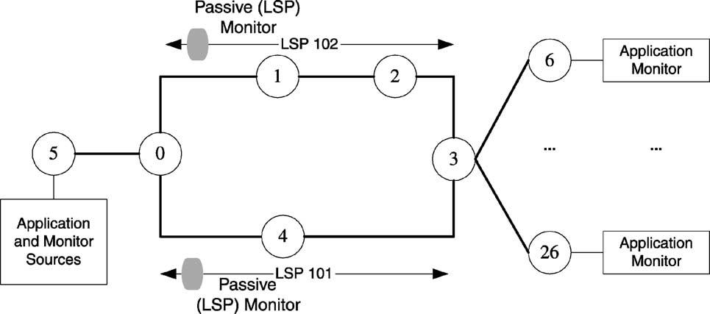

S. Van den Berghe et al. / Future Generation Computer Systems 19 (2003) 291–302

Fig. 5. Topology and setup used in this evaluation.

297

in the network, capable of handling 10 Mb/s. These
links are part of two distinctive LSPs: LSP 101 follow-
ing the shortest path (0–4–3) and LSP 102 following
(0–1–2–3). Two passive monitors are installed, exam-
ining the tunnel statistics related to these lsps.
In this conﬁguration, trafﬁc is generated by 20 ap-
plications. Corresponding to these applications, classi-
ﬁers are installed and added to an LSP group together
with the two LSPs. Trafﬁc is generated by the appli-
cations during 15 s, followed by a 3 s off-period. With
each ‘trafﬁc burst’ the rate per application is increased
In consecutive steps of 0.10 Mb/s, generating a total
trafﬁc of between 11 and 15 Mb/s in steps of 2 Mb/s
(this is repeated at every test run, so for instance traf-
ﬁc mapping decisions taken at 11 Mb/s are not reset
after the burst). After each burst, the cumulative loss
of all the applications for that burst is evaluated. Ini-
tially, all trafﬁc is mapped to the shortest path LSP.
A corresponding experiment was performed on a
testbed of Linux routers, equipped with the enhanced
Linux kernel as described earlier. A Smartbits 2000
system was used for trafﬁc generation, generating the
same pattern as the trafﬁc in the simulator (except
for the fact that no off-time was predeﬁned, since the
Smartbits needs some time by itself to read-out results
and conﬁgure the hardware for the next burst).

4.2. Results

Not running any re-mapping algorithms, this leads
to the result shown in Figs. 6 and 7, using one-way
loss as the evaluated metric. This chart also contains

the result of the same test on a Linux testbed (the same
topology as the one used for the simulator). As a ref-
erence, the graph also shows the test without mapping
to an LSP on the testbed. This performance shows
that introducing MPLS deteroriates the performance
by only a small factor, and all three are close to the the-
oretical value (e.g. sending 15 Mb/s on a 10 Mb/s link,
theoretically yields a loss of 33.33, 32.9% in the plain
set-up—thanks to some spare room in the queues—
and 33.42% by using MPLS).
For each of the LSP, two evaluators were then cre-
ated with corresponding rules. This resulted in a con-
ﬁguration in which the weight was increased if the
loss was smaller than 0.01% and was decreased (in-
cluding a re-mapping of trafﬁc) according to Eq. (1).
with upper and lower bounds of, respectively, 2 and
5% one-way loss. In the experiment, the read-out pe-
riod of the passive reporters providing the input was
twice per second.
A ﬁrst striking observation is that the simulator
shows a much greater performance improvement than
with the real testbed experiments. There are several
reasons for this:
• When transporting measurement results to the eval-
uators, during the evaluation, during the decision
process, etc. the simulator is actually stopped, while
in the real testbed this happens asynchronously. As
a result, the decision to swap trafﬁc has a much later
impact on the real testbed.
• Re-mapping trafﬁc is disruptive on the testbed.
While mapping trafﬁc from one LSP on another is

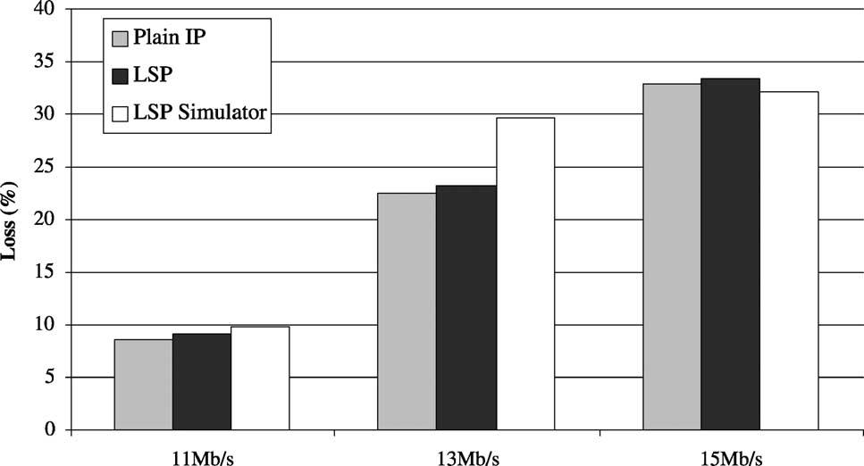
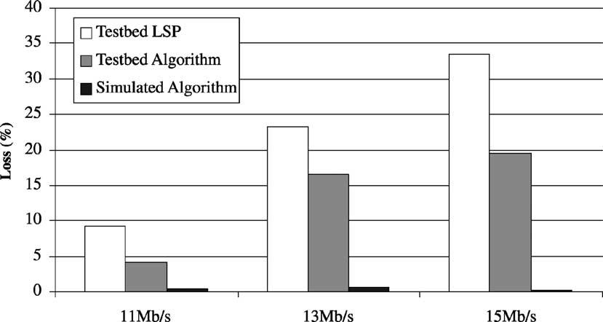

298

S. Van den Berghe et al. / Future Generation Computer Systems 19 (2003) 291–302

Fig. 6. Reference performance.

done through modiﬁcation in the simulator, in the
testbed this is done through a remove–add com-
bination of ﬁrewall rules. In between the removal
and addition, trafﬁc is dropped before entering
the LSP. Hence, the end-to-end application-level
performance deteriorates, but the LSP-loss is not
touched.
• Generally speaking, the testbed implementation is
currently a proof-of-concept implementation to val-
idate functionality. It makes heavy use of CORBA-
calls, XML-parsing, debugging output, ﬂat ﬁle input
and output, etc. As a result, the effect of the ﬁrst
bullet point is even worse.

Despite these practical obstacles, the testbed results
clearly show a performance improvement (although it
is not as impressive as the simulation results) by re-
lying on measurement-based, short-term trafﬁc engi-
neering.
A second conclusion can be drawn from the evalua-
tion with different read-out times for each rate (Fig. 8).
Here, in the simulation environment, the experiment
is done with a read-out period varying between four
times per second (so 0.25 s between each poll) and
every 2.5 s.
The improved performance with shorter inter-mea-
surement times is quite logic. It means more probes,

Fig. 7. Simulator and testbed performance improvement.

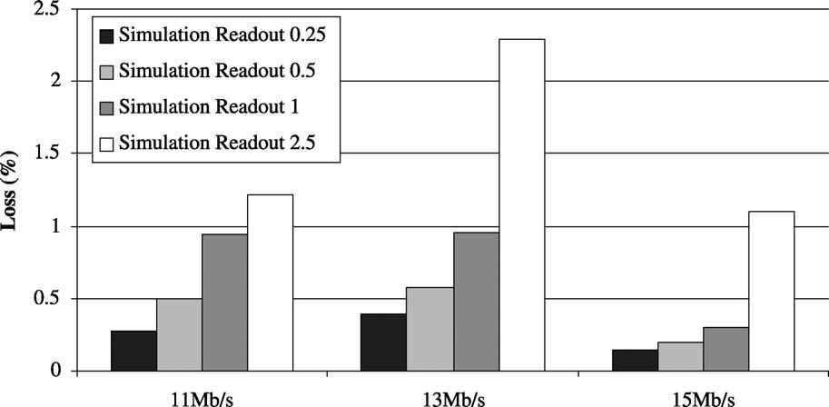
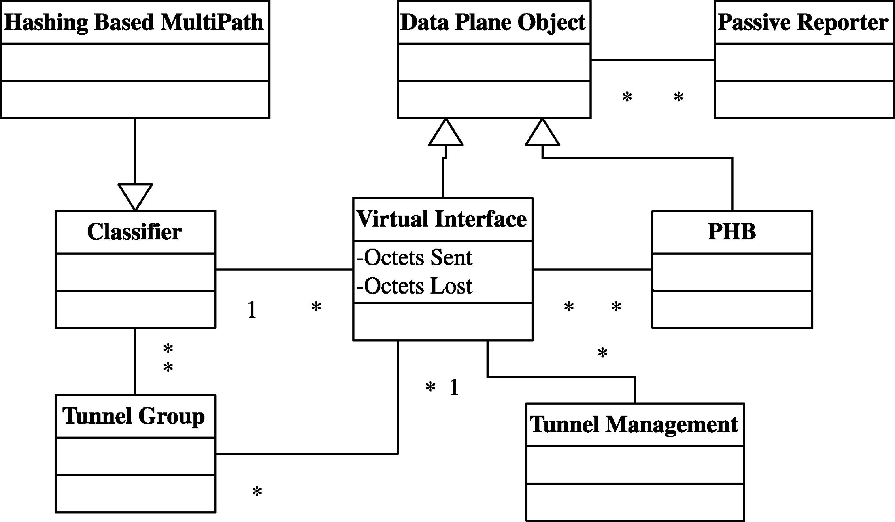

S. Van den Berghe et al. / Future Generation Computer Systems 19 (2003) 291–302

Fig. 8. Simulator and testbed performance improvement.

299

and as a result more opportunities to react and switch
trafﬁc to a less loaded LSP. On the other hand, it of
course increases the burden of evaluating the delays.

5. Future applications

5.1. Generic model for tunnel management

While MPLS is currently being used for creating
alternative paths in the network, the approach is easily
implemented on top of other tunnelling mechanisms,

like Generic Routing Encapsulation (GRE [5]) or se-
cured VPN tunnels. Generally speaking, the model
shown in Fig. 2 can be reused, with the LSP replaced
with a more generic tunnel representation. As an ex-
ample of this approach, a generic model (Fig. 9) is
currently under study, where the tunnel is abstracted
through the use of virtual interfaces, and where the
tunnel encapsulation of trafﬁc is transparent for the
ingress classiﬁcation. Mapping trafﬁc to a tunnel is
then transformed to setting a route via an interface.
In Linux, virtual interfaces are supported for a num-
ber of mechanisms including MPLS, GRE and PPP.

Fig. 9. Generalized model.

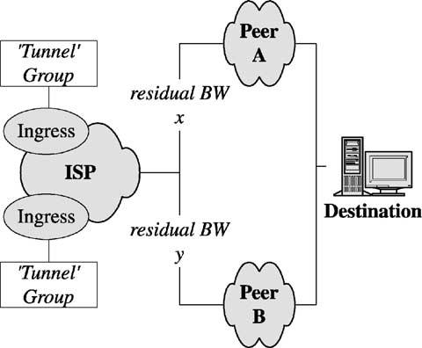

300

S. Van den Berghe et al. / Future Generation Computer Systems 19 (2003) 291–302

Furthermore, several advanced routing mechanisms
(like source routing and hashing-based multipath) are
available in the ‘off-the-shelf’ Linux kernels [7], and
can be used to map trafﬁc on the interfaces.
For monitoring, the generic nature of this model
cannot be maintained so easily, due to the fact that not
all tunnels are bi-directional. In the case of MPLS for
instance, there is a virtual interface at the ingress, but
not at the egress. In this case, the transport of statistics
(e.g. the ‘octets received’) from egress to ingress can
be done either by the tunnel management block, or
through more low-level functions (e.g. by attaching
it as an explicit congestion notiﬁcation to the regular
messages RSVP refresh messages).

5.2. Other algorithm inputs

In all the previous sections, unidirectional end-to-
end loss has been used as a metric to drive the trafﬁc
mapping and the emphasis was on the management
of tunnels. However, other metrics and applications
can beneﬁt from the given approach. For instance in
the network shown in Fig. 10 in which a network
domain is depicted that peers with two other domains.
If this peering is (e.g. contractually) limited to a certain
bandwidth, the domain can use the residual bandwidth
at each of the peering points to direct the mapping
of trafﬁc entering the network, destined to a subnet
advertised by both peers.
This mapping does not even require a tunnel mech-
anism to be used, but can be done by selecting differ-
ent ‘gateways’ at the domain ingress.

Fig. 10. Using residual bandwidth at peering points.

6. Conclusions

In this paper, a short-term trafﬁc engineering was
presented, based on the policy-based management
paradigm. A formal model and corresponding con-
ﬁguration language was described. This allowed
for a ﬂexible proof-of-concept software architec-
ture to be built, both on top of a simulator and on
a Linux-based router testbed. In the latter case, the
necessary modiﬁcation done on the Linux router was
described.
From the experiments it was shown that the algo-
rithm, although very simple in nature, was able to han-
dle some short-term ﬂuctuations. On the other hand,
by comparing the results retrieved from simulation, to
those in real-life, it became clear that more has to be
done than just a proof-of-concept implementation in
order to achieve a more optimal performance enhance-
ment (although already a signiﬁcant improvement was
made).
In a last section, it was shown that the concepts, al-
though now aimed at MPLS tunnels, could be applied
to a wider range of problems dealing with congestion
avoidance.
As presented, the current evaluated environment re-
lies only on the reactive use of monitoring feedback
in a local (ingress only) node. Since no information is
exchanged between these processes, the network-wide
stability is not guaranteed. As a result another level
of control needs to be introduced, which can perform
trafﬁc engineering on a longer timescale, and which
uses—amongst other information—feedback from the
architecture presented to do so.

Acknowledgements

The authors would like to thank the participants
in the TEQUILA project for the interesting discus-
sions concerning the subject of two-level trafﬁc en-
gineering. The authors would also like to thank Wai
Sum Lai, Blaine Christian and Richard W. Tibbs for
co-developing the basic monitoring ideas within the
IETF. Part of this work has been supported by the
Flemish Government through IWT scholarships and
by the Information Society Technologies (IST) Tequila
project, which is partially funded by the European
Commission.






S. Van den Berghe et al. / Future Generation Computer Systems 19 (2003) 291–302

301

References

[1] J.L. Alberi, T. Chen, S. Khurana, A. Mcintosh, M. Pucci, R.
Vaidyanathan, Using real-time measurements in support of
real-time network management, in: Proceedings of the Passive
and Active Monitoring Workshop, 2001.
[2] R. Cole, R. Dietz, C. Kalbﬂeisch, D. Romascanu, A
framework for synthetic sources for performance monitoring,
Internet Draft, Internet Engineering Task Force, Work in
Progress, 2001.
[3] D. Durham, et al., The COPS (Common Open Policy Service)
Protocol, RFC 2748, Internet Engineering Task Force, 2000.
[4] A. Elwalid, C. Jin, S. Low, I. Widjaja, MATE: MPLS
adaptive trafﬁc engineering, in: Proceedings of the Infocom,
Anchorage, Alaska, April 2001.
[5] D. Farinacci, T. Li, S. Hanks, D. Meyer, P. Traina, Generic
routing encapsulation (GRE), RFC 2784, Internet Engineering
Task Force, March 2000.
[6] F. Le Faucheur, L. Wu, B. Davie, S. Davari, P. Vaananen,
R. Krishnan, P. Cheval, J. Heinanen, MPLS support of
differentiated services, Internet Draft, Internet Engineering
Task Force, Work in Progress, April 2001.
[7] B. Hubert, et al., Linux advanced routing and trafﬁc con-
trol howto. http://www.Linuxdoc.org/HOWTO/Adv-Routing-
HOWTO.html.
[8] INTEC Ghent University, DiffServ Extensions for MPLS for
Linux. http://dsmpls.atlantis.rug.ac.be.
[9] W. Lai, B. Christian, R. Tibbs, S. Van den Berghe, A frame-
work for internet trafﬁc engineering measurement, Internet
Draft, Internet Engineering Task Force, Work in Progress,
2001.
[10] Network Simulator (ns-2). The ns Manual. The VINT Project.
http://www.isi.edu/nsnam/ns/doc/index.html.
[11] S. Shalunov, B. Teitelbaum, M. Zekauskas, A one-way delay
measurement protocol, Internet Draft, Internet Engineering
Task Force, Work in Progress, 2001.
[12] Spirent, Smartbits 2000. http://www.netcomsystems.com.
[13] P. Trimintzios, I. Andrikopoulos, G. Pavlou, P. Flegkas, D.
Grifﬁn, P. Georgatsos, D. Goderis, Y. T’Joens, L. Georgiadis,
C. Jacquenet, R. Egan, A management and control architecture
for providing IP differentiated services in MPLS-based
networks, IEEE Commun. Mag. 39 (5) (May 2001).

S. Van den Berghe graduated in Com-
puter Science at the University of Gent in
1999. In July 1999, he joined the Broad-
band Communications Networks Group
and he is preparing a PhD in January
2001, he was granted an IWT scholar-
ship. His research interests are mainly
the area of Quality of Service and Traf-
ﬁc Engineering in IP. He is focusing
on measurement-based Trafﬁc Engineer-
ing in a DiffServ/MPLS/MultiPath environment. He is active

in the IST TEQUILA project, development of DiffServ sup-
port for MPLS in the Linux community and has published,
next to several papers, an Internet Draft on the requirements
for measurement architectures for use in Trafﬁc Engineered IP
Networks.

P. Van Heuven graduated in Computer
Science at the University of Gent in 1998.
His graduation thesis (“Computer busses
and caches in future processors”) exam-
ined the beneﬁts of pre-fetching in fu-
ture processors by means of simulation.
In August 1998, he joined the Broadband
Communications Networks Group and he
is preparing a PhD. In January 1999, he
was granted an IWT scholarship. His re-
search interests include mainly the area of Quality of Service,
Trafﬁc Engineering and resilience in IP and MPLS. He worked
on the ACTS Ist ACI project and is currently working on the
Ist TEQUILA project. He is also the maintainer of the open
source “RSVP-TE daemon for DiffServ over MPLS under Linux”
project.

J. Coppens joined the IBCN research
group in 2001 after studying computer
science at Ghent University. He special-
izes in (Linux) Trafﬁc Control mecha-
nisms and is responsible for the Linux
part of a generic adaptation layer (GAL),
an abstraction layer for different router
platforms, in the IST Tequila project. His
research interests are Quality of Service,
Trafﬁc Engineering, network monitoring
and distributed computing. While doing a PhD on monitoring in
Content Distribution Networks, he is currently active in the IST
Scampi project.

F. De Turck received his MSc degree in
Electronic Engineering from the Ghent
University, Belgium in June 1997. In May
2002, he obtained the PhD degree in Elec-
tronic Engineering from the same uni-
versity. From October 1997 to Septem-
ber 2001, Filip De Turck was research
assistant with the Fund for Scientiﬁc Re-
search Flanders, Belgium (FWO-V). At
the moment, he is afﬁliated with the De-
partment of Information Technology of the Ghent University as
a post-doctoral researcher of the FWO-V. His research interests
include scalable software architectures for telecommunication net-
work and service management, performance evaluation and opti-
mization of routing, admission control and trafﬁc management in
telecommunication systems.



302

S. Van den Berghe et al. / Future Generation Computer Systems 19 (2003) 291–302

P. Demeester received his PhD degree
from the University of Gent at the De-
partment of Information Technology (IN-
TEC) in 1988. He became professor at the
University of Gent where he is teaching
telecommunication networks and where
he is responsible for the IBCN research
group. He is senior member of IEEE and
he was or is member of several techni-
cal program committees. He was involved
in about 15 European ESPRIT, RACE and ACTS projects. He
was co-editor of two special issues of the IEEE Communications

Magazine: “Optical Networks Research in Europe, 1997” and “Sur-
vivable Communication Networks, 1999”. He was chairman of the
First International Workshop on the design of Reliable Commu-
nication Networks (DRCN98) and he is member of the editorial
board of the journals: “OPTICAL NETWORKS MAGAZINE” and
“JOURNAL PHOTONIC NETWORK COMMUNICATIONS”. He
has published over 300 articles and papers in the ﬁeld of op-
toelectronics and broadband networks. His current interests are
related to broadband communication networks (IP, ATM, SDH,
WDM, access) and include network planning, network and ser-
vice management, telecommunications software, inter-networking,
etc.

